**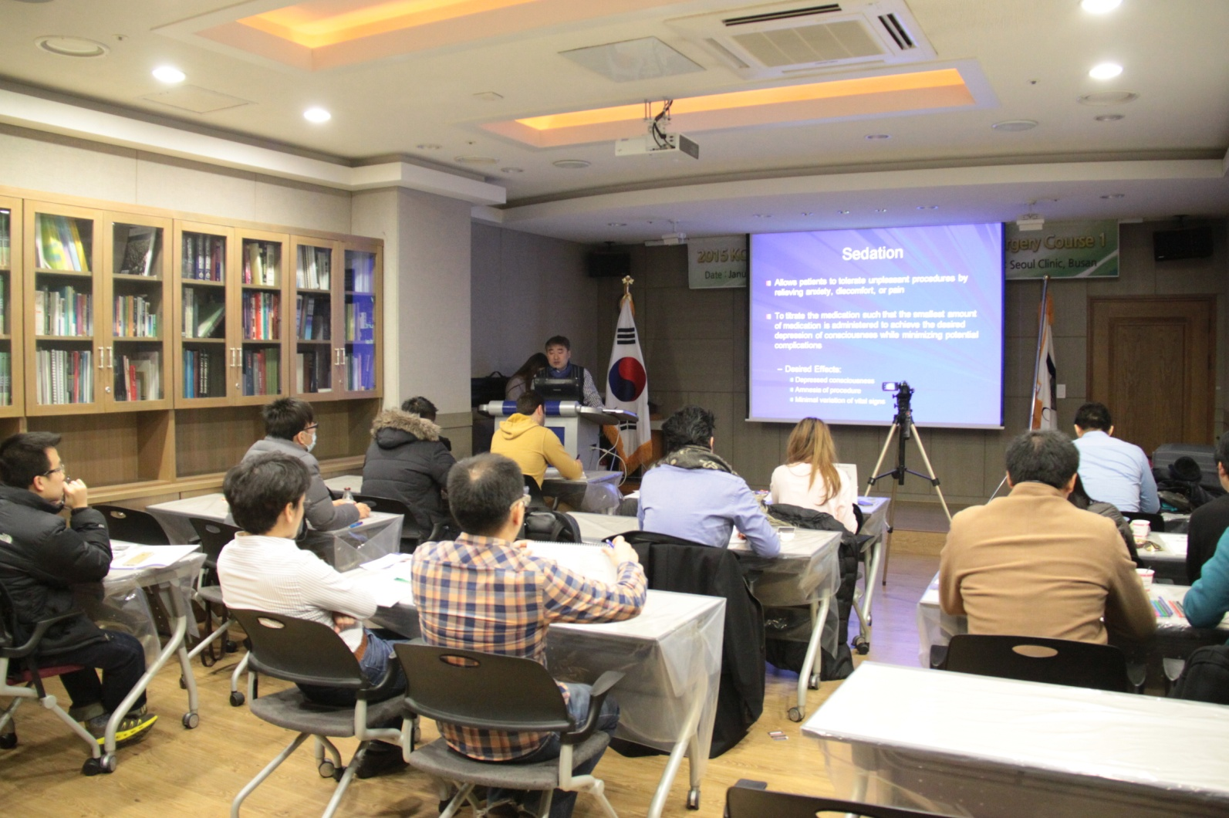**

**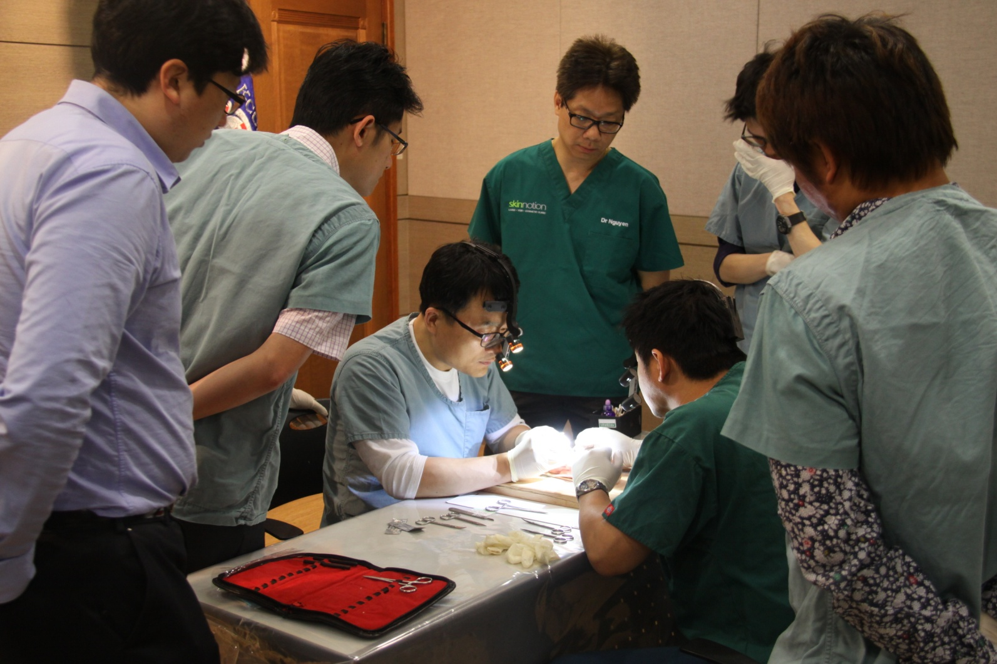**

**KCCS International Membership Course**

**Basic Cosmetic Surgery Course** 1

**October 30th ~ November 1st, 2015 (Fri.~Sun.)**

**Bangkok, Thailand**

**2015**

|  |  |
| --- | --- |
| Greetings!  KCCS has launched an educational system for the fields of Asian cosmetic surgery since 2006. We started offering fellowship course in 2014 and this is the second year KCCS offering fellowship course to doctors who are interested to pursue their career in cosmetic surgery or to current cosmetic surgery practitioners who want to enhance their cosmetic surgery skills and knowledge.  Currently, our fellowship course members are from Hong Kong, Malaysia, Indonesia, Iran, Taiwan and Thailand. There are around 10 doctors from 2014 batch and 5 doctors from 2015 batch who are expected to sit for their fellowship graduation examination and become a fellow of KCCS in 2015.  We have decided to launch International Membership Course in Bangkok starting this year for more doctors to join our course. This course enables members from nearby countries to join our classes easily with minimum cost and time spent for traveling. Doctors who have completed the Thailand Membership Course will be granted Fellowship of KCCS.  In the 1st class of the course, we will include basic skills for our members. Subjects include anatomy, aesthetics, suture technique, emergency care, thread lifting, and facial fat grafting and liposuction.  Currently, we have International Membership Course members from Hong Kong, Philippines, Malaysia and Thailand. Hopefully we can have more members from South East Asian countries like Vietnam or Myanmar to join us in the course.  This will be a golden opportunity to enhance your cosmetic surgical knowledge and skills.  We welcome you to be a member of the International Membership Course! | |
| President of KCCS | Founder of KCCS |
| Seong-Yik Han M.D., DDS., Ph.D., FKCCS, KBCS | Kyoung-Jin(Safi) Kang M.D., Ph.D., FKCCS & KBCS |
| **IMG_1178.JPG**IMG_1178.JPGIMG_1178.JPGIMG_1178.JPGIMG_1178.JPGIMG_1178.JPG | |

**Program**

**October 30th, 2015 (Fri.)**

|  |  |  |
| --- | --- | --- |
| **Time** | **Subject** | **Professor** |
| 09:00~10:00 | Anatomy and Anesthesia for cosmetic surgery  Face and Body | Dr. Kyoung-Jin(Safi) Kang |
| 10:00~11:30 | Basic Instruments, machine, and materials for cosmetic Surgery |
| 11:30~12:30 | DIYS of instruments: familiarize and learn the correct method of using the instruments |
| 12:30~13:30 | Lunch | |
| 13:30~15:00 | Basic Suture technique : DIYS | Dr. Kyoung-Jin(Safi) Kang |
| 15:00~17:00 | Advanced suture technique and flap surgery : DIYS |
| 17:00~18:00 | Dressing and Sterilization for surgery : Lecture and Video | Dr. Montri Khammoonta |

**October 31st, 2015 (Sat.)**

|  |  |  |
| --- | --- | --- |
| **Time** | **Subject** | **Professor** |
| 09:00~11:00 | Local Anesthesia  1) Preparation of solution  1) How to do local infiltration and sensory nerve block : DVD  2) Application of Tumescent anesthesia : DVD | Dr. Kyoung-Jin(Safi) Kang |
| 11:00~12:00 | Sedation for cosmetic surgery | Dr. Jung-Yeon Kim |
| 12:00~12:30 | Emergency care in OR |
| 12:30~14:00 | Lunch | |
| 14:00~17:00 | Practice of intubation and CPR : DIYS | Dr. Jung-Yeon Kim |
| 17:00~18:00 | Lecture and Video : Thread Lifting | Dr. Kyoung-Jin(Safi) Kang |
| 18:00~ | Dinner | |

**November 1st, 2015 (Sun.)**

|  |  |  |
| --- | --- | --- |
| **Time** | **Subject** | **Professor** |
| 09:00~09:30 | Facial fat grafting | Dr. Kyoung-Jin(Safi) Kang |
| 09:30~10:30 | Facial liposuction |
| 10:30~12:30 | Design for facial thread lifting and facial lipoplasty : DIYS |
| 12:30~13:30 | Lunch | |
| 13:30~14:30 | Live surgery and Practice  Thread lifting | Dr. Montri Khammoonta |
| 14:30~16:30 | Live surgery and Practice  Fat grafting and liposuction | Dr. Nuttorn Narupaves |
| 16:30~18:00 | Practice of facial sensory nerve block and tumescent infiltration: DIYS | Dr. Kyoung-Jin(Safi) Kang |

**\*Program is subject to change without any prior notice**

**Introduction**

|  |  |
| --- | --- |
| **Date** | **October 30th ~ November 1st, 2015, 2015 (Fri.~Sun.)** |
| **Venue** | **Day 1 ~ Day 2: October 30th ~ 31st, 2015 (Friday~Saturday)**  **Pathumwan Princess Hotel- B1 Floor Executive Junction**  444 MBK Center, Phayathai Road, Wangmai, Pathumwan, Bangkok, 10330  **Day 3: November 1st, 2015 (Sunday)**  **Masterpiece Clinic**  199/6,201 Phayathai Road, Phatumwan district, Bangkok, 10330 |
| **Hosted by** | **G:\KCCS Logo\kccs최종변환.jpg** KCCS (Korean College of Cosmetic Surgery) |
| **Sponsored by** | **MasterPiece Clinic by Dr.Sae** Masterpiece Clinic |
| **Speaker** | |  |  | | --- | --- | | F:\사진\가족사진\내사진\kangphotos.jpg | **Kyoung-Jin(Safi) Kang, M.D., Ph.D., FKCCS & KBCS** 태극기.jpg  Director of Seoul Cosmetic Surgery Clinic  Member of Korean Association of Anatomist  Founder and Former President of Korean College of Cosmetic Surgery  Diplomat of International Board of Cosmetic Surgery  Editor of the Journal of Cosmetic Surgery and Medicine  Medical consultant of the Plastic and Cosmetic Center, East Hospital, Tongji University, Shanghai, P.R. China  Visiting Professor of Dalian University affiliated Bravou Hospital, Sichuan, PR China | | 33 김중연.jpg | **Jung-Yeon Kim, M.D., FKCCS** 태극기.jpg  Head of Dep. of Anesthesiology of Busan Adventist Hospital Anesthesia specialist  Member of The Korean Society of Anesthesiologists  Member & Professor of KCCS  Former Vice President of K.B.S. Cosmetic Surgery Clinic in Busan | |  | **Montri Khammoonta, M.D. & FKCCS** Flag of Thailand.svg  Director of Pruksamedical clinic, NakhonPathom , Thailand  Flight Lieutenant of Ramratchanivet Army Hospital,Petchaburi, Thailand  Diploma Thailand Board in Family Medicine  Board Certified Aesthetic Medicine, USA (AAAM)  Diploma and Fellowship of Korean College of Cosmetic Surgery (KCCS) | | D:\CHOI\자료\외국 회원 사진\nuttorn.jpg | **Nuttorn Narupaves, M.D. & FKCCS Flag of Thailand.svg**  Director of The Skin Clinic  Diploma in Dermatologist, University of Wales  Diploma Thai Board in Family Medicine  Board Certified Aesthetic Medicine (US)  Diploma and Fellowship of Korean College of Cosmetic Surgery (KCCS) | |
| **Language** | English |
| **Registration fee** | **Early Bird: Payment made before Sept. 20th:**   |  |  |  |  | | --- | --- | --- | --- | | **New Member** | **Member** | **Diploma Member** | **Fellow** | | **$2,600** | **$2,000** | **$1,500** | **$1,000** | |  |  |  |  |   **Payment made after Sept. 20th:**   |  |  |  |  | | --- | --- | --- | --- | | **New Member** | **Member** | **Diploma Member** | **Fellow** | | **$2,900** | **$2,300** | **$1,800** | **$1,300** | |  |  |  |  |   2015 KCCS International Membership Course: USD 9,900 (Total 6 Classes, 18 days)  \* In order to join this workshop, dr. must become a member of KCCS. Total price for this workshop will be USD 2,600/ USD 2,900 (Membership Application Fee Included). Please email us your membership application form together with the workshop registration form.  \* When you wire payment to us, please pay remittance charge separately. |
| **Registration** | You can register in this course by submitting your registration form to KCCS by fax +82-51-248-7765 or e-mail : kccs7777@hotmail.com  **Based on first-come, first-served, please register ASAP.** |
| **Awards for participants** | Each doctor will be awarded a Certificate of Attendance of the workshop issued by the KCCS after finishing the workshop. |
| **International**  **Membership** | If you want to join International member of KCCS, Please fill the International Membership and send us registration form by email or fax. Member application fee is $600. |
| **Payment** | **(Bank Information)**  Bank name : SHINHAN Bank Branch name : Busan Banking Center  AD : 2, Donggwang-Dong 1Ga, Jung-Gu, Busan 600-020, Korea  BIC code : SHBKKRSE Beneficiary Name: KCCS (Kyoung-Jin Kang) Account Number : 180-005-881845  \* Please pay **remittance charge** separately when you wire the application fee. |
| **Map of the venue** |  |
| **Hotel** | 1. Pathumwan Princess Hotel  www.pprincess.com  Please contact KCCS for room reservation: Corporate price (Tax & Breakfast included)   |  |  |  | | --- | --- | --- | | Superior Room  (34 sq m.) | Twin OR Double | 4,100 Baht |   2. Novotel Bangkok Siam Square  www.novotel.com/  3. Siam @ Siam Design Hotel and Spa  www.siamatsiam.com |
| **Notification** | It is important to KCCS that you enjoy this workshop. If you have any special needs due to a disability, Please let us know in advance so that we may try to accommodate your needs.  **1.** **Cancellation Policy**  ⅰ) In case that the workshop schedule(date or venue) is changed by unavoidable circumstances of KCCS, which leading to change accommodation, flight ticket, KCCS would provide commission occurred by *changing the hotel and flight ticket* to attendees who registered already before changing the venue or date. (It is not applicable to companion) This clause is effective when KCCS changes the schedule within 1 month before the workshop.  ⅱ) In case that an attendee would like to cancel the registration or could not attend the workshop because of personal affairs or The workshop will be canceled due to unavoidable situation of KCCS, *Cancellation of International membership of KCCS* is not permitted when you register this workshop and KCCS International membership simultaneously.  **2. Photography/Audio/Visual Taping Restrictions**  ⅰ) There is strictly no photography or audio or visual taping allowed during surgery without express prior written permission of the KCCS and the speaker. Anyone found photographing or taping without authorization will be required to immediately surrender the film or tape with no reimbursement or further recourse.  **3. Refund policy**  Deadline for refund is 4 weeks before the date of the Workshop   |  |  |  | | --- | --- | --- | | 80% | 50% | 20% | | ~ September 24, 2015 | Sept. 25 ~ Oct. 1, 2015 | October 2 ~ 8, 2015 |   (A $100 administrative processing fee will be subtracted from each approved refund)  **4. Disclaimer**  The KCCS disclaims any and all liability for injury or other damages resulting to any individuals attending a session for all claims which may arise out of the use of the techniques demonstrated or discussed therein by such individuals, whether these claims shall be asserted by a physician or any other person.  *All speakers, topics and schedules and method of presentation are subject to change without prior notification* and will not be considered reason for refund requests.  **5.** By remitting the registration fee, registrant will be admitted on condition, and by said attendance at this meeting agrees that he/she will not photograph, audio tape, transmit, or aid in transmitting any description, account, picture, or other reproduction of any part of the meeting.  Breach of the foregoing will automatically terminate your registration and the registrant shall be liable for all consequential and other applicable damages.  By remitting payment for this workshop, you also agree to abide by all KCCS policies and procedures and by the policies included in this registration package. |
| **Contact** | For registration, accommodation and further information, please do not hesitate to contact: 1) Website : www.koreancosmeticsurgery.com  2) E-mail: kccs7777@hotmail.com,  3) Mobile: +82-10-2265-6686  4) Office: +82-51-247-7776 |

**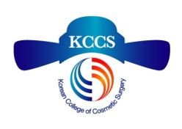**

**Korean College of Cosmetic Surgery**

**KCCS International Membership**

**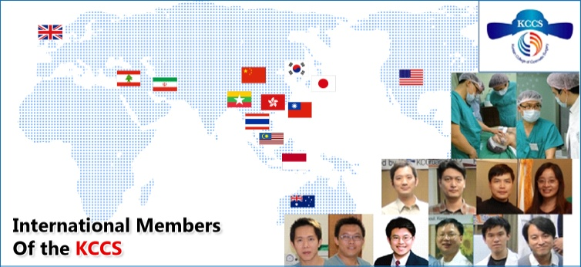**

**See the Difference!**

The KCCS is an institute where passion, leadership and rich experience for the improvement and education of Korean cosmetic surgery and medicine have been accumulated. The KCCS has a wide range of training system which consists of specialized doctors including **human anatomy**, which is fundamental in the field of cosmetic surgery, **oral and maxillofacial surgery, plastic and reconstructive surgery, otolaryngology, ophthalmology, obstetrics and gynecology, urology, general surgery and dermatology.** The ultimate goal of KCCS is providing information and improving standards in every field of cosmetic surgery & medicine. Members of the KCCS can work as a member of expert group in Asia as well as in Korea. Moreover, you can improve your ability by showing and sharing your knowledge and skills, which will result in presenting patients joy and happiness. Also, you can contribute to your community by developing your hospital.

1. Discover the Benefits of KCCS International Membership

**KCCS International Members can receive:**

**I) Discounts on registration fee in various events:**

ⅰ. Live workshops

ⅱ. Special Hands-on Courses

ⅲ. Annual Conferences

ⅳ. Cadaver dissection Workshop

**II) Certificate of KCCS International Membership**

**2.** **You can register for KCCS International Membership by filling out the application form & send to KCCS by fax +82-51-248-7765 or E-mail: kccs7777@hotmail.com**

**3. Membership Application Fee: USD 600**

**4. Kindly please send payment to:**

|  |  |
| --- | --- |
| Bank name | SHINHAN Bank |
| Branch name | Busan Banking Center |
| Address | 2, Donggwang-Dong 1 Ga, Jung-Gu, Busan 600-020, Korea |
| BIC code | SHBKKRSE |
| Name of Beneficiary | KCCS (Kyoung-Jin Kang) |
| Account Number | 180-005-881845 |

◈ Note: Please pay **remittance charge** separately when you wire the application fee.

**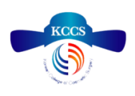International Membership Application Form of KCCS**

|  |  |  |  |  |  |
| --- | --- | --- | --- | --- | --- |
| **Full Name** |  | | | | Picture |
| **Given Name** |  | | Surname: | |
| **Format of Name in Certificate** | 1) Full Name, M.D.  2) Dr. Full Name Please choose ONE only. | | Date of Birth :  /(Y) /(M) /(D) | |
| Gender: Male / Female | |
| **Email** |  | | | License Number: ( ) | |
| **Hospital** | Name: |  | | Tel.(H/P): | |
| Address: |  | | Tel.(O): | |
| **Home** | Address |  | | Tel.(H): | |
| **Attainments**  **In Scholarship** | Graduated university |  | | Entered year:  ( ) | |
| Master’s course |  | | Special study:  ( ) | |
| **Training**  **Course** | Intern | ( ) Hospital | | | |
| Resident | ( ) Hospital | | | |
| Special study |  | | License number: ( ) | |
| **Joined**  **Society** | 1.  2. | | | | |
| **About**  **Cosmetic**  **Surgery** | Cosmetic career | 1. | | | |
| 2. | | | |
| 3. | | | |
| Duration of hospital |  | | | |
| Main clinic | Skin & Dermatology: ( ) | | | |
| Face cosmetic surgery: ( ) | | | |
| Body cosmetic surgery: ( ) | | | |
| Possible live surgery |  | | | |

**\* KCCS International Membership Application Fee: USD 600**

클립보드Early Bird: Before Sept. 20th

|  |
| --- |
| **For Office Use Only** |
| Date : |
| Fee : |
| Received : |

|  |
| --- |
| **KCCS International Membership Course**  **Basic Cosmetic Surgery Course 1** |
| Physician Name : |
| Gender : |
| Original Field of Training : |
| Address : |
| City : State : Zip : |
| Mobile Phone No. : |
| E-mail : |
| Experience of Cosmetic Surgery : |
| Medical License No. : |
| **Format of Name in Certificate (Please choose ONE only)**  1) Full Name, M.D. □ 2) Dr. Full Name □  New member of KCCS □ Member of KCCS □ Diploma member □ Fellow □  **Registration fee** |
| |  |  |  |  | | --- | --- | --- | --- | | **New Member** | **Member** | **Diploma Member** | **Fellow** | | **$2,600** | **$2,000** | **$1,500** | **$1,000** |   **Send Payment To** (Please pay remittance charge separately) **:**   |  |  | | --- | --- | | Bank name : Shinhan bank | Beneficiary : KCCS (Kyoung-Jin Kang) | | ABA : SHBKKRSE | Branch : Busan Banking Center | | Acc. No.: 180-005-881845 | Address : 2, Donggwang-Dong 1Ga, Jung-Gu, Busan 600-020, Korea |   **\* Please pay remittance charge separately when you wire the registration fee.**  **아시아Questions?** Call +82.51.247.7776 or +82-10-2265-6686  Fax +82.51.248.7765  E-mail : kccs7777@hotmail.com  Signature : |

**Registration Form**

클립보드After Sept. 20th

|  |
| --- |
| **For Office Use Only** |
| Date : |
| Fee : |
| Received : |

|  |
| --- |
| **KCCS International Membership Course**  **Basic Cosmetic Surgery Course 1** |
| Physician Name : |
| Gender : |
| Original Field of Training : |
| Address : |
| City : State : Zip : |
| Mobile Phone No. : |
| E-mail : |
| Experience of Cosmetic Surgery : |
| Medical License No. : |
| **Format of Name in Certificate (Please choose ONE only)**  1) Full Name, M.D. □ 2) Dr. Full Name □  New member of KCCS □ Member of KCCS □ Diploma member □ Fellow □  **Registration fee** |
| |  |  |  |  | | --- | --- | --- | --- | | **New Member** | **Member** | **Diploma Member** | **Fellow** | | **$2,900** | **$2,300** | **$1,800** | **$1,300** |   **Send Payment To** (Please pay remittance charge separately) **:**   |  |  | | --- | --- | | Bank name : Shinhan bank | Beneficiary : KCCS (Kyoung-Jin Kang) | | ABA : SHBKKRSE | Branch : Busan Banking Center | | Acc. No.: 180-005-881845 | Address : 2, Donggwang-Dong 1Ga, Jung-Gu, Busan 600-020, Korea |   **\* Please pay remittance charge separately when you wire the registration fee.**  **아시아Questions?** Call +82.51.247.7776 or +82-10-2265-6686  Fax +82.51.248.7765  E-mail : kccs7777@hotmail.com  Signature : |

**Registration Form**

**Information on 2015 KCCS International Membership Course**

**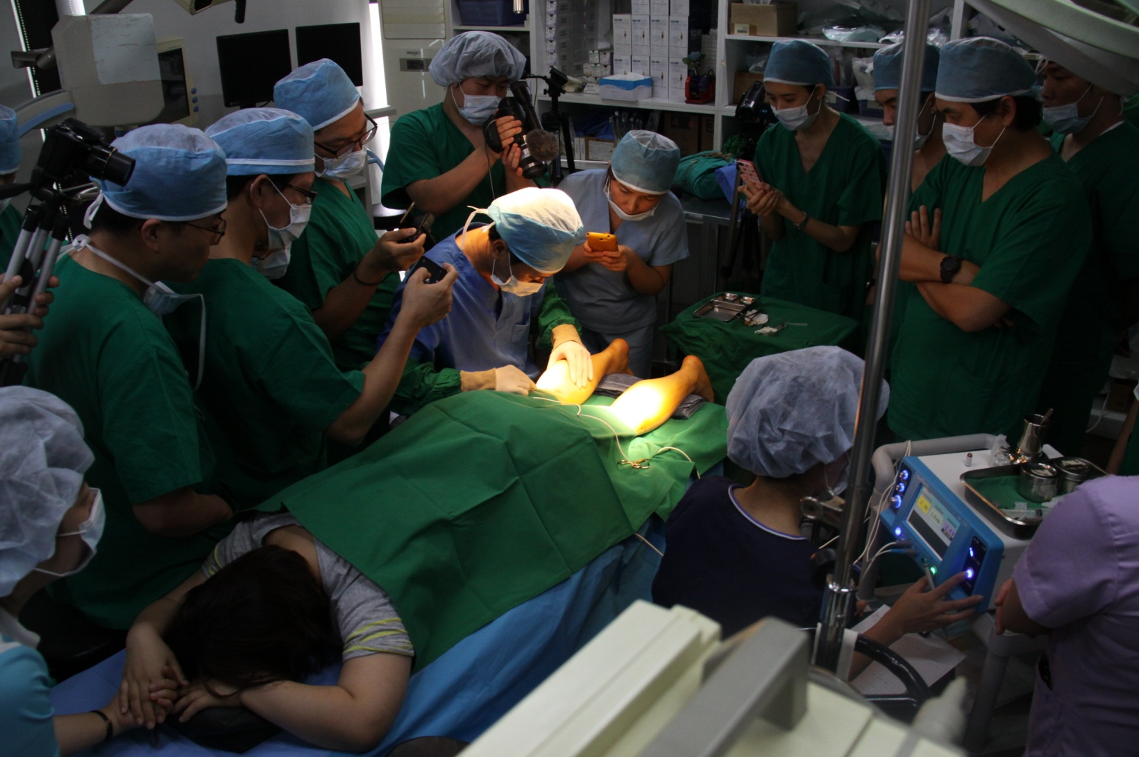**

|  |  |  |  |
| --- | --- | --- | --- |
| Course | Subjects | Days | Venue |
| 4 Classes  (Class I, II, III, IV) | -Lectures  -Live Video Tranmission  -Live surgery  -Cadaver dissection | 11 Days | Thailand |
| 2 Classes  (Class V, VI) | -Live surgery  -Exam & International Conference | 7 Days | Korea |

**Introduction**

▶ **Level**: Basic

▶ **Class**: Total 6 Courses (18 days)

▶ **Course fee**: USD 9,900

▶ **Language**: English

▶ **Venue**: Thailand & South Korea.

▶ **Number of applicants**: Limited to 40 Doctors per year

▶ **Completion of the Course and pass the examination**: Fellow of KCCS (FKCCS) will be guaranteed.

▶ **Types of education**: Lecture, Practice, Live surgery

▶ **Acquisition process of Fellowship**: Completing the course -> Written examination -> Fellowship Graduation Ceremony

▶**KCCS International Membership:** Before joining Membership Course, all applicants must apply for KCCS International Membership (Membership application fee already included in registration fee).

**Schedule**

|  |  |  |  |
| --- | --- | --- | --- |
| **Days** | **Subjects** | **Faculty** | **Venue** |
| Class I: 3 days  Lectures, Live Demonstrations & Live Video Transmission | - Anatomy for cosmetic surgery  - Basic surgical skills  - Emergency care under anesthesia  - Minimally invasive face lifting using threads, filler, etc.  - Facial lipoplasty using fat Injection and liposuction | - Kyoung-Jin Kang  - Jung-Yeon Kim  - Montri Khammoonta  - Kosit Ieochai | Thailand |
| Class II: 3 days  Lectures, Live Demonstrations & Live Video Transmission | - Upper and lower blepharoplasty  - Rhinoplasty | - Woong-Chul Choi  - Geun-Uck Chang | Hong Kong |
| Class III: 3 days  Lectures, Live Demonstrations & Live Video Transmission | - Skin rejuvenation and Laser therapy  - Application of PRP and ADSC (Adipose-drived Stem cells) to cosmetic treatment  - Updated methods of Botox and Filler  - Breast augmentation with implants | - Jung-Hyun Yoon  - Jeong-Ho Seo | To be  determined |
| Class IV: 2 days | Cadaver dissection workshop | KCCS Professors | Thailand |
| Class V: 3 days  (Live surgery observation) | - Minimal invasive calf reduction surgery  - Varicose vein treatment  - Medical and surgical body contouring  - Introduction of facial bone surgery  - Face lifting (including forehead)  - Hair transplantation | - Ue-Kyoung Hwang  - Yi-Kyoung Shin  - Weon-Kee Jang  - Seong-Yik Han  - Dong-Young Yang  - Kwang-Young Kang | Seoul/Busan, Korea |
| Class VI: 4 days | - Pre-examination course  - Examination (written) and Certification  - 2016 KCCS International Conference | KCCS Professors | Seoul, Korea |

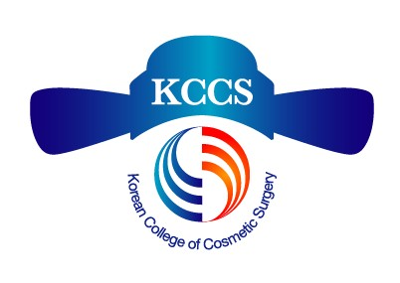

**2015 KCCS international membership Course Application Form**

|  |  |  |  |
| --- | --- | --- | --- |
| Full Name |  | | |
| Surname |  | Gender |  |
| Given Name |  | E-Mail |  |
| Format of Name in Certificate | 1) Full Name, M.D. 2) Dr. Full Name  \* Please choose ONE only | | |
| Clinic name |  | Clinic phone number |  |
| Cell phone number |  | Medical license number |  |
| Graduated University |  | Specialist |  |
| Career of  Cosmetic Surgery | 1. | | |
| 2. | | |
| 3. | | |

**Course Schedule *\* All program is subject to change***

|  |  |  |  |
| --- | --- | --- | --- |
| **Days** | **Subjects** | **Faculty** | **Venue** |
| Class I: 3 days  Lectures, Live Demonstrations & Live Video Transmission | - Anatomy for cosmetic surgery  - Basic surgical skills  - Emergency care under anesthesia  - Minimally invasive face lifting using threads, filler, etc.  - Facial lipoplasty using fat Injection and liposuction | - Kyoung-Jin Kang  - Jung-Yeon Kim  - Montri Khammoonta  - Kosit Ieochai | Thailand |
| Class II: 3 days  Lectures, Live Demonstrations & Live Video Transmission | - Upper and lower blepharoplasty  - Rhinoplasty | - Woong-Chul Choi  - Geun-Uck Chang | Hong Kong |
| Class III: 3 days  Lectures, Live Demonstrations & Live Video Transmission | - Skin rejuvenation and Laser therapy  - Application of PRP and ADSC (Adipose-drived Stem cells) to cosmetic treatment  - Updated methods of Botox and Filler  - Breast augmentation with implants | - Jung-Hyun Yoon  - Jeong-Ho Seo | To be  determined |
| Class IV: 2 days | Cadaver dissection workshop | KCCS Professors | Thailand |
| Class V: 3 days  (Live surgery observation) | - Minimal invasive calf reduction surgery  - Varicose vein treatment  - Medical and surgical body contouring  - Introduction of facial bone surgery  - Face lifting (including forehead)  - Hair transplantation | - Ue-Kyoung Hwang  - Yi-Kyoung Shin  - Weon-Kee Jang  - Seong-Yik Han  - Dong-Young Yang  - Kwang-Young Kang | Seoul/Busan, Korea |
| Class VI: 4 days | - Pre-examination course  - Examination (written) and Certification  - 2016 KCCS International Conference | KCCS Professors | Seoul, Korea |

**\* Please transfer the registration fee (USD 9,900) to KCCS account as below:**

|  |  |
| --- | --- |
| Bank name | SHINHAN Bank |
| Branch name | Busan Banking Center |
| Address | 2, Donggwang-Dong 1Ga, Jung-Gu, Busan 600-020, Korea |
| BIC code | SHBKKRSE |
| Name of Beneficiary | KCCS (Kyoung-Jin Kang) |
| Account Number | 180-005-881845 |

**\*\*\* Please pay remittance charge separately when you wire the registration fee**